**Recyclable Materials**

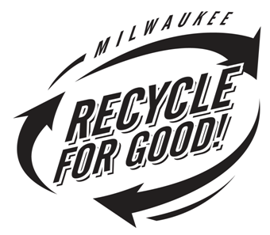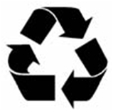

Aluminum beverage containers, Steel cans & Empty aerosol cans

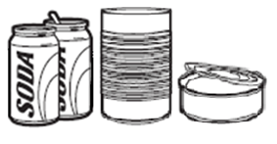

Newspaper, Magazines, Catalogs, Phonebooks, Mixed paper & Mail

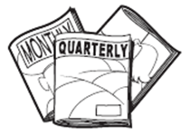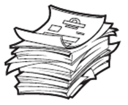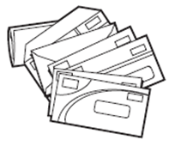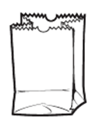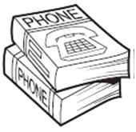

Glass bottles & Jars

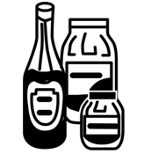

Plastic containers #1 & #2

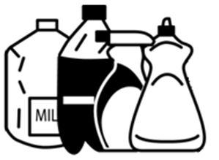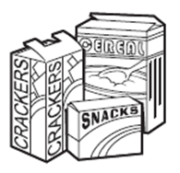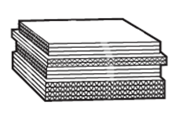

Cardboard & Paperboard (flattened)

## **Please** empty and rinse all containers. Flatten cardboard and plastics.

**NO** window glass, light bulbs, ceramics, china, plastic bags, Styrofoam, unmarked plastics, needles or “sharps”

City logo[1].tif

**THANK YOU FOR YOUR HELP.**

**Together we are conserving natural resources and landfill space.**