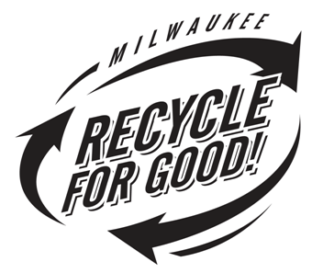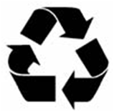
Recyclable Materials

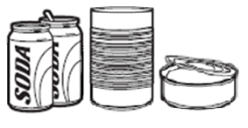
Aluminum beverage containers, Steel cans & Empty aerosol cans
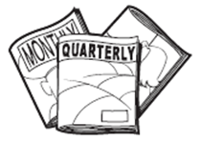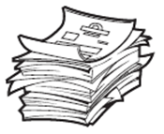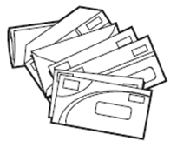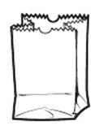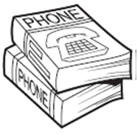
Newspaper, Magazines, Catalogs, Phonebooks, Mixed paper & Mail

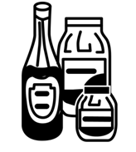
Glass bottles & Jars
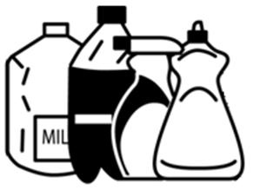
Plastic containers #1 & #2

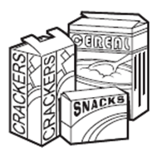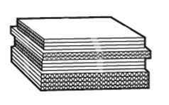
Cardboard & Paperboard (flattened)

Please empty and rinse all containers. Flatten cardboard and plastics.
NO window glass, light bulbs, ceramics, china, plastic bags, Styrofoam, unmarked plastics, needles or “sharps”

THANK YOU FOR YOUR HELP.
Together we are conserving natural resources and landfill space.

